TICKETS Italian Grand Prix F1 - Monza - сентябрь
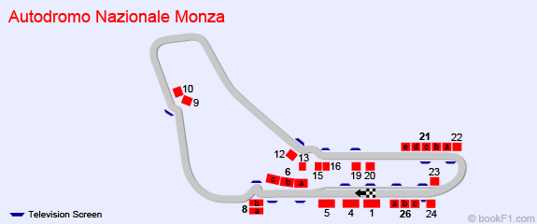
 | PRICE 1 ticket | INFO
High Speed 6 A (Weekend) | EUR 263.00
High Speed 6 B (Weekend) | EUR 445.00
High Speed C (6c) weekend | EUR 544.00
Ascari 16 (Weekend) | EUR 401.00
Ascari Two 13 (Weekend) | EUR 445.00
Ascari Three 12 (Weekend) | EUR 401.00
Ascari One (15) weekend | EUR 564.00
Central 1 (Weekend) | EUR 741.00
General Admission (Sunday) | EUR 134.00
General Admission (Saturday) | EUR 102.00
General Admission (Friday) | EUR 85.00
General Admission (Weekend) | EUR 145.00
Right Lateral Destra 26 A (Weekend) | EUR 544.00
Right Lateral Destra 26 B (Weekend) | EUR 445.00
Right Lateral 26 C (Weekend) | EUR 303.00
Lateral Parabolic 21 A (Weekend) | EUR 303.00
Lateral Parabolic 21 B (Weekend) | EUR 303.00
Lateral Parabolic 21 C (Weekend) | EUR 216.00
Lateral Parabolic 21 D (Weekend) | EUR 216.00
Laterale Parabolica 21 E (Weekend) | EUR 326.00
Left Lateral 4 (Weekend) | EUR 445.00
Outer Ascari 19 (Weekend) | EUR 401.00
Parabolica 22 (Weekend) | EUR 401.00
Inner Parabolic 23 A | EUR 216.00
Inner Parabolic 23 B (Weekend) | EUR 303.00
Piscina 5 (Weekend) | EUR 303.00
First Variant 8 A File P - Z5 (Weekend) | EUR 445.00
First Variant 8 B Row A-O (Weekend) | EUR 401.00
Roggia 10 (Weekend) | EUR 401.00
Second Variant 9 (Weekend) | EUR 445.00
Vedano 24 (Weekend) | EUR 303.00

